QUICK mEDICAL CARE

TEAM 1



NZIENGUI MOUANDA Benoit Diele

[nzienguimoua@student.agh.edu.pl](mailto:nzienguimoua@student.agh.edu.pl)

KAMGAIN FOTSEU ROMIAL

[kamgaingfots@student.agh.edu.pl](mailto:kamgaingfots@student.agh.edu.pl)

NGAKOU TATSING Franck Wilfried

[ngakoutatsin@student.agh.edu.pl](mailto:ngakoutatsin@student.agh.edu.pl)

NTENDA KAMDEM Mel Stevens

[ntendakamdem@student.agh.edu.pl](mailto:ntendakamdem@student.agh.edu.pl)

**Authors**

01 avril 2024

**Directed by: Małgorzata Żabińska**

zabinska@agh.edu.pl

Table des matières

INTRODUCTION 2

1. Subject of a Project 2

2. Team members and their responsibilities 3

I. Roles (Actors) and preliminary proposals of Use Cases 4

1. List of Actors (roles in the system, who need some functions from the system) 4

2. List of Use Cases for each Actor/Role 5

a. Patient Role 5

b. Receptionist Role 5

c. Doctor role 6

d. Nurse role 6

e. Owner role 6

f. Accounting office role 6

3. Scenarios / table descriptions – developed Users’ Stories with details 7

a. Management of appointments and payments 7

b. Medical services management 9

c. Medication stock management 11

d. Financial management 13

II. USE CASE DIAGRAMS (UCD) 16

1. Appointment and Payment Management (Author: ROMIAL) 16

2. Medical Services Management (Author: MEL STEVENS) 17

3. Medication Stock Management (Author FRANCK) 17

4. Financial Management (Author: BENOIT) 18

III. Sequence Diagram (SD) 19

1. Sequence Diagram 1 (SD 1) 19

2. Sequence Diagram 2 (SD 2) 23

3. Sequence Diagram 3 (SD 3) 28

4. Sequence Diagram 4 (SD 4) 37

IV. Proposal of a class Diagram 40

Conclusions 40

# INTRODUCTION

## Subject of a Project

* **Description of a Project:**

Patients can register online or in-person with the Receptionist for appointments. They can purchase medical services such as consultations, injections, or first aid directly through the system. Additionally, basic medicines are available for purchase. Billing is handled by the Receptionist, and the Owner of QMedCare manages bill collection and sends them to the Accounting Office monthly. QMedCare maintains its own inventory of basic medical supplies managed by healthcare professionals. The Owner oversees the management of QMedCare, utilizing reports generated by the Receptionist to monitor sales, medicament purchases, and stock levels. The Accounting Office manages financial matters based on monthly reports provided by the Owner.

* **Comments and explanations of the title:**

"Quick Medical Care (QMedCare)" suggests a focus on swift and efficient healthcare services. The inclusion of "Quick" emphasizes the rapid delivery of medical care, which aligns with the system's objective. "QMedCare" is a concise and memorable abbreviation, reinforcing the system's purpose of providing timely medical attention.

* **Assumptions:**
* The system prioritizes quick and efficient medical care delivery, allowing patients to register and schedule appointments promptly.
* Medical services such as consultations, injections, and first aid are readily accessible for purchase through the system.
* The Receptionist handles billing, allowing patients to settle their bills conveniently.
* The Owner oversees the overall management of QMedCare, including financial operations and inventory management.
* Healthcare professionals manage the stock of basic medical supplies available at the facility.
* Generated reports assist in decision-making processes, enabling effective resource allocation and management.
* The Accounting Office manages financial matters based on monthly reports provided by the Owner, ensuring financial stability and compliance.

## Team members and their responsibilities

* Mel Stevens NTENDA Kamdem ntendakamdem@student.agh.edu.pl (Leader) 25 %
* Responsible for: share the tasks and uploading and for the below mentioned.
* Use cases - scenarios of: Medical Services Management
* UCD for Medical Services Management Fig. No 3.2
* Sequence Diagram (SD) for Medical Services Management Fig. No 5
* Class Diagram (CD)
* ROMIAL KAMGAING FOTSEU 25%
* Responsible for: list of actors, list of use cases for each Actor/role
* Use cases - scenarios of Management of appointments and payments.
* UCD for Management of appointments Fig. No 3.1
* SD for Management of appointments Fig. No 4
* Class Diagram
* FRANCK WILFRIED NGAKOU TATSING 25%
* Responsible for: the final report document, list of Use cases for each Actor/role
* Use cases - scenarios of Medication Stock Management
* UCD for Medication Stock Management Fig. No 3.3
* SD for Medication Stock Management Fig. No 6
* Class Diagram
* Benoit DIELE NZIENGUI MOUANDA 25%
* Responsible for: Comments and Explanations of the title, Assumption,
* Use cases - scenarios of Financial Management
* UCD for Financial Management Fig. No3.4
* SD for Financial Management Fig. No 7
* Class Diagram

# Roles (Actors) and preliminary proposals of Use Cases

## List of Actors (roles in the system, who need some functions from the system)

* Patients:
* Needs: Online registration to make an appointment, payment for medical services and medications, medical consultation, purchase of basic medications.
* Actor: They are considered main actors because they interact directly with the system to access medical services.
* Receptionist:
* Needs: Management of appointments, collection of payments, generation of reports on sales of services and medications, communication with patients.
* Actor: Manages interactions with patients and ensures the proper functioning of the system at reception level.
* Nurses:
* Needs: Provide medical services, manage stock of basic medicines, report restocking needs.
* Actor: They are involved in the provision of medical services and the management of stocks of basic medicines.
* Doctors:
* Needs: Provide medical services, manage stock of basic medicines, report restocking needs.
* Actor: They are involved in the provision of medical services and the management of stocks of basic medicines.
* Owner:
* Needs: Collection of invoices, purchase of medical items to complete stock, overall management of the system.
* Actor: Responsible for the general supervision and financial management of the system.
* Accountant:
* Needs: Receipt of invoices, processing of financial documents, monitoring of expenses and income.
* Actor: Manages the financial aspects of the system and ensures compliance with regulations.

## List of Use Cases for each Actor/Role

### Patient Role

* What:
* Schedule appointments: Patients need to book appointments conveniently to access healthcare services at their preferred times.
* Make payments for medical services and medications: Patients must settle bills promptly to complete their healthcare transactions and receive necessary treatments or medications.
* Why:
* Efficient appointment scheduling ensures that patients receive timely medical attention, improving overall healthcare outcomes.
* Seamless payment processes enhance patient satisfaction and encourage continued engagement with the healthcare provider.

### Receptionist Role

* What:
* Manage appointment schedules: Receptionists organize patient appointments to optimize the workflow and minimize waiting times.
* Assist patients in booking appointments: Receptionists guide patients through the appointment booking process, ensuring accuracy and clarity.
* Handle payments and issue receipts: Receptionists facilitate financial transactions, providing patients with documentation of their payments.
* Why:
* Well-organized appointment schedules streamline clinic operations and enhance the patient experience.
* Clear communication and assistance with payments improve patient satisfaction and trust in the healthcare provider.

### Doctor role

* What:
* Provide medical consultations and treatments: Physicians deliver expert medical care, diagnosing and treating patients' health conditions.
* Manage the stock of basic medications: Physicians monitor medication inventory levels to ensure availability for patient treatments.
* Why:
* Quality medical consultations and treatments promote patient health and well-being, fostering trust and loyalty to the healthcare provider.
* Adequate medication management supports uninterrupted patient care and treatment efficacy, enhancing overall healthcare service delivery.

### Nurse role

* What:
* Administer injections and provide first aid: Nurses deliver essential medical interventions promptly and competently to address patient needs.
* Manage the stock of basic medications: Nurses monitor medication supplies to maintain inventory levels and facilitate timely restocking.
* Why:
* Efficient delivery of medical interventions by nurses contributes to positive patient outcomes and satisfaction with the healthcare provider.
* Proper medication management by nurses ensures availability of essential medications for patient care, minimizing treatment delays and disruptions.

### Owner role

* What:
* Collect invoices and send them to the accounting office monthly: MedCare owners oversee financial transactions, ensuring timely processing and accuracy.
* Purchase additional medical supplies: MedCare owners procure necessary resources to sustain clinic operations and meet patient demand.
* Why:
* Timely invoice processing and financial oversight support the clinic's financial health and compliance with regulatory requirements.
* Strategic procurement of medical supplies ensures sufficient resources for patient care, promoting operational efficiency and service quality.

### Accounting office role

* What:
* Receive invoices from the medical facility and manage financial matters: Accounting office’s handle financial transactions and maintain accurate records.
* Communicate with the medical facility regarding financial transactions and reports: Accounting office’s facilitate communication and collaboration to ensure financial transparency and compliance.
* Why:
* Effective financial management by the accounting office promotes fiscal responsibility and sustainability for the medical facility.
* Clear communication and collaboration facilitate informed decision-making and regulatory compliance, supporting the clinic's overall success.

## Scenarios / table descriptions – developed Users’ Stories with details

### Management of appointments and payments

* UC1-1: Register online.
* Actor: Patient
* Prerequisites: None.
* Trigger: Access to the QMedCare website.
* Main scenario:
* The patient completes the registration form with their personal information.
* The system validates the information and creates an account for the patient.
* The patient receives an email confirmation with their login credentials.
* Alternative scenario:
* The information provided by the patient is incorrect.
* The system displays an error message and asks the patient to correct the information.
* UC1-2: Make an appointment.
* Actor: Patient
* Prerequisites: Be connected to your QMedCare account. Trigger: Selecting a date and time for the appointment.
* Main scenario:
* The patient selects the desired date and time for their appointment.
* The system checks availability and confirms the appointment.
* The patient receives an email confirmation with appointment details.
* Alternative scenario:
* No availability on the selected date and time.
* The system asks the patient to choose another available date/time.
* UC1-3: Make a payment.
* Actor: Patient, Receptionist
* Prerequisites: Have a confirmed appointment.
* Trigger: Arrival of the patient at the reception for the consultation.
* Main scenario:
* The patient goes to reception to pay for their consultation.
* The receptionist enters the consultation details into the system. The patient makes payment in cash or by card.
* The system records the payment and generates a receipt for the patient.
* Alternative scenario:
* Card payment is refused.
* The receptionist offers the patient another payment method.
* UC1-4: Consult appointments.
* Actor: Patient
* Prerequisites: Have at least one appointment scheduled.
* Trigger: Need to check appointment details.
* Main scenario:
* The patient logs into their QMedCare account.
* He accesses the “My appointments” section where he can see upcoming appointments.
* The system displays the appointment details, including date, time and doctor.
* Alternative scenario: None.
* UC1-5: cancel appointments.
* Actor: Patient
* Prerequisites: Have a confirmed appointment.
* Trigger: Patient's decision to cancel an appointment.
* Main scenario:
* The patient accesses the “My appointments” section on their account.
* He selects the appointment he wishes to cancel.
* The system asks for confirmation.
* The patient confirms the cancellation and receives a confirmation by email.
* Alternative scenario: None.
* UC1-6: Receive received.
* Actor: Patient
* Prerequisites: Have made a payment.
* Trigger: Patient request for a receipt.
* Main scenario:
* After making a payment, the patient requests a receipt.
* The receptionist generates a receipt from the system.
* The system displays the receipt with transaction details.
* The receptionist prints the receipt for the patient.
* Alternative scenario: None.
* UC1-7: Generate reports.
* Actor: Owner, Receptionist
* Prerequisites: Have data to generate reports.
* Trigger: Need to see system performance.
* Main scenario:
* The owner or receptionist accesses the "Reports" section of the system.
* They select the filter criteria for the report (for example, by date, by service type).
* The system generates the requested report.
* The report is displayed on screen and can be exported to PDF or Excel format.
* Alternative scenario: None.
* UC1-8: Connected.
* Actor: Patient
* Prerequisite: Have a register online
* Trigger: patient wants to connect to his customer account
* UC1-9: Appointment confirmed.
* Actor: Patient
* Prerequisite: Make an appointment

AUTHOR : By ROMIAL

### Medical services management

* UC2-01: Providing Medical advice.
* Level: Blue (middle for function)
* Objective: Providing medical advice to users.
* Context: Users seeking medical guidance or information.
* Main actor: Medical advisor.
* Precondition: The medical advisor is available and logged into the system.
* Trigger: User requests medical advice
* UC2-02: Administering injections.
* Level: Blue (middle for function)
* Objective: Administering injections to patients.
* Context: Patients requiring medication through injections.
* Main actor: Medical staff (e.g., nurses, doctors).
* Precondition: Patient is prepared and the appropriate medication is available.
* Trigger: Patient requires an injection as part of their treatment.
* UC2-03: Providing first aid.
* Level: Blue (middle for function)
* Objective: Administering first aid to individuals in need.
* Context: Emergencies or situations requiring immediate medical assistance.
* Main actor: Trained medical personnel or first responders.
* Precondition: First aid kit and trained personnel are available.
* Trigger: Incident or accident requiring immediate medical attention.
* UC2-04: Purchasing Medications
* Level: Blue (middle for function)
* Objective: Facilitating the purchase of medications.
* Context: Users needing to acquire prescribed or over-the-counter medications.
* Main actor: Pharmacist or pharmacy staff.
* Precondition: User has a valid prescription (if required) and sufficient funds.
* Trigger: User requests to purchase medication.
* UC2-05: consultation.
* Level: Blue (middle for function)
* Objective: Conducting medical consultations with patients.
* Context: Patients seeking professional medical advice or treatment plans.
* Main actor: Medical practitioner (e.g., doctor, specialist).
* Precondition: Patient's medical history and relevant documents are available.
* Trigger: Patient schedules an appointment for a consultation.
* UC2-06: Generating reports.
* Level: Blue (middle for function)
* Objective: Generating medical reports for patients or internal use.
* Context: Documenting patient visits, treatments, and medical outcomes.
* Main actor: Administrative staff or medical professionals.
* Precondition: Relevant patient information and medical data are recorded.
* Trigger: Completion of a medical procedure or consultation prompting the need for documentation.

Author : by MEL STEVEN

### Medication stock management

* UC3-00: Login
* Objective: Logging in to the system.
* Context: Authorization of the user to store and process their data.
* Main actor: User (not logged in)
* Precondition: User is not logged in.
* Trigger: User starts the login process.
* UC3-01: Monito stock
* Objective: Monitoring medication stock levels to ensure adequacy for patient treatments and care.
* Context: Authorization of the user to access and monitor medication stock information.
* Main actor: Doctor/Nurse
* Precondition: The doctor/nurse is logged into the system.
* Trigger: The doctor/nurse accesses the medication stock monitoring page.
* UC3-02: order medication
* Objective: Ordering medication to replenish stock levels based on demand.
* Context: Authorization of the user to place medication orders.
* Main actor: Owner
* Precondition: Owner is logged into the system.
* Trigger: The Owner identifies the need for medication replenishment.
* UC3-03: Receive deliveries.
* Level: Blue (middle for function)
* Objective: Receiving medication deliveries and updating stock records accordingly.
* Context: Authorization of the user to receive and process medication deliveries.
* Main actor: Doctor/Nurse
* Precondition: The doctor/nurse is logged into the system.
* Trigger: The doctor/nurse receives a notification of an incoming medication delivery.
* UC3-04: Update information
* Objective: Updating medication information in the stock management system.
* Context: Authorization of the user to modify medication records.
* Main actor: Doctor/Nurse
* Precondition: The doctor/nurse is logged into the system.
* Trigger: The doctor/nurse identifies changes or updates required for medication records.
* UC3-05: Check expiration
* Objective: Regularly checking the expiration dates of stocked medications.
* Context: Authorization of the user to access expiration date information.
* Main actor: Doctor/Nurse
* Precondition: The doctor/nurse is logged into the system.
* Trigger: The system prompts the doctor/nurse to perform expiration date checks.
* UC3-06: Manage returns.
* Objective: Handling returns of expired or damaged medications.
* Context: Authorization of the user to process medication returns.
* Main actor: Doctor/Nurse
* Precondition: The doctor/nurse is logged into the system.
* Trigger: The doctor/nurse identifies expired or damaged medications that need to be returned.
* UC3-07: Generate reports.
* Objective: Generating reports on medication stock status and related metrics.
* Context: Authorization of the user to access report generation tools.
* Main actor: Doctor/Nurse
* Precondition: The doctor/nurse is logged into the system.
* Trigger: The doctor/nurse requests a report on medication stock status.
* UC3-08: Handle invalid password.
* Objective: Handling the scenario when the user enters an invalid password during login.
* Context: Verification of user credentials during login process.
* Main actor: System
* Precondition: User attempts to log in with an invalid password.
* Trigger: The system detects that the password entered by the user does not match the stored credentials.

Author : by FRANCK

### Financial management

* UC4-01: Sending invoices.
* Purpose: Send invoices to the appropriate recipients
* Context: Process of sending invoices to customers or designated recipients
* Main actor: Owner
* Precondition: Invoices are generated, collected and ready to send
* Trigger: The user selects the option to send invoices from the user interface or an automated system triggers the sending periodically.
* UC4-02: Collection of invoices
* Objective: Collect invoices from different sources
* Context: Process for gathering invoices issued by suppliers or external sources Main actor: Receptionist
* Precondition: Invoices are available to collect from various suppliers or external sources.
* Trigger: The user starts the invoice collection process via the user interface or an automated system initiates collection at predefined intervals.
* UC4-03: Tracking expenses and income
* Objective: Track and record expenses and income in the system
* Context: Process for monitoring and managing incoming and outgoing monetary flows Main actor: Receptionist
* Precondition: The system has access to relevant financial data, such as bank transactions, invoices paid and income received.
* Trigger: The user accesses the financial tracking interface or the system automatically starts updating expenses and income at regular intervals.
* UC4-04: Analysis of financial reports
* Objective: Review and interpret financial reports generated by the system
* Context: Process of evaluating financial performance, trends and key indicators from data contained in financial reports
* Main actor: Accountants
* Precondition: Financial reports are generated and available for analysis.
* Trigger: The user accesses the financial reporting analysis interface or initiates a specific analysis request from the system.
* UC4-05: Communication with accountants
* Objective: Exchange information and documents with external or internal accountants.
* Context: Process of transmitting relevant financial data and coordinating with accountants for specific needs such as tax reporting, auditing, etc.
* Main actor: Receptionist
* Precondition: Accountants are identified and appropriate communication channels established.
* Trigger: User initiates communication with accountants based on financial management needs, such as tax return preparation, account verification, etc.
* UC4-06: Generation of monthly reports
* Objective: Create consolidated reports for a specific monthly period
* Context: Process of compiling financial data and generating summary reports for a given month Main actor: Accountant
* Precondition: Financial data for the month in question is available and integrated into the system.
* Trigger: The user initiates the generation of monthly reports by selecting the relevant month from the user interface or the system automatically triggers the generation at the end of each month.
* UC4-07: Payment of suppliers
* Objective: Make payments due to suppliers for goods or services provided.
* Context: Process for processing supplier invoices and executing payments according to agreed terms. Main actor: owner
* Precondition: Supplier invoices are verified and approved, and the necessary funds are available.
* Trigger: The user initiates the supplier payment process after verifying and validating the corresponding invoices in the system.

Author : by BENOIT

# USE CASE DIAGRAMS (UCD)

## Appointment and Payment Management (Author: ROMIAL)

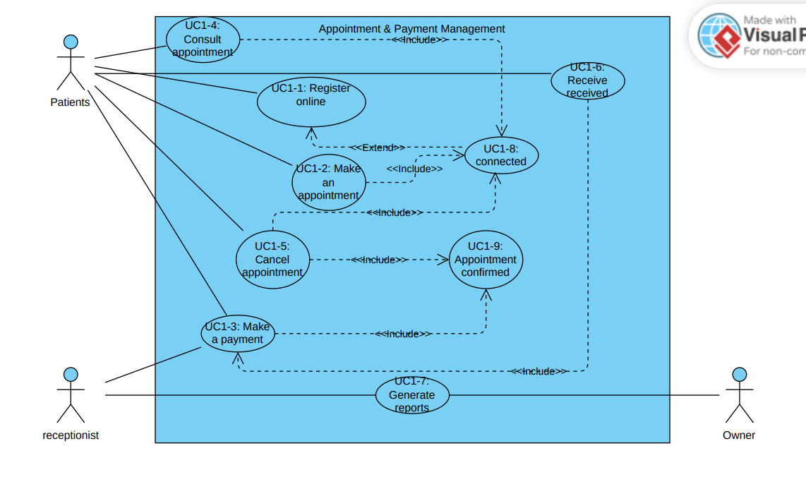

## Medical Services Management (Author: MEL STEVENS)

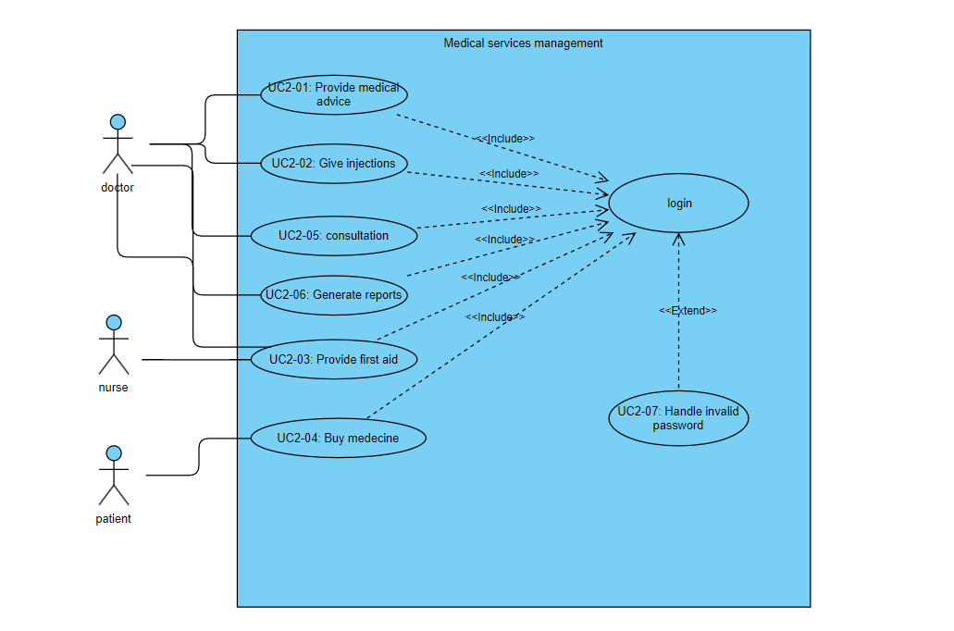

## Medication Stock Management (Author FRANCK)

## Financial Management (Author: BENOIT)

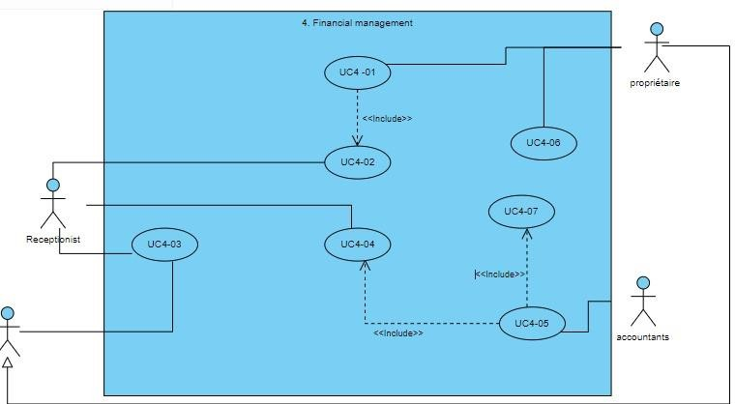

Figure 3.4

# Sequence Diagram (SD)

## Sequence Diagram 1 (SD 1)

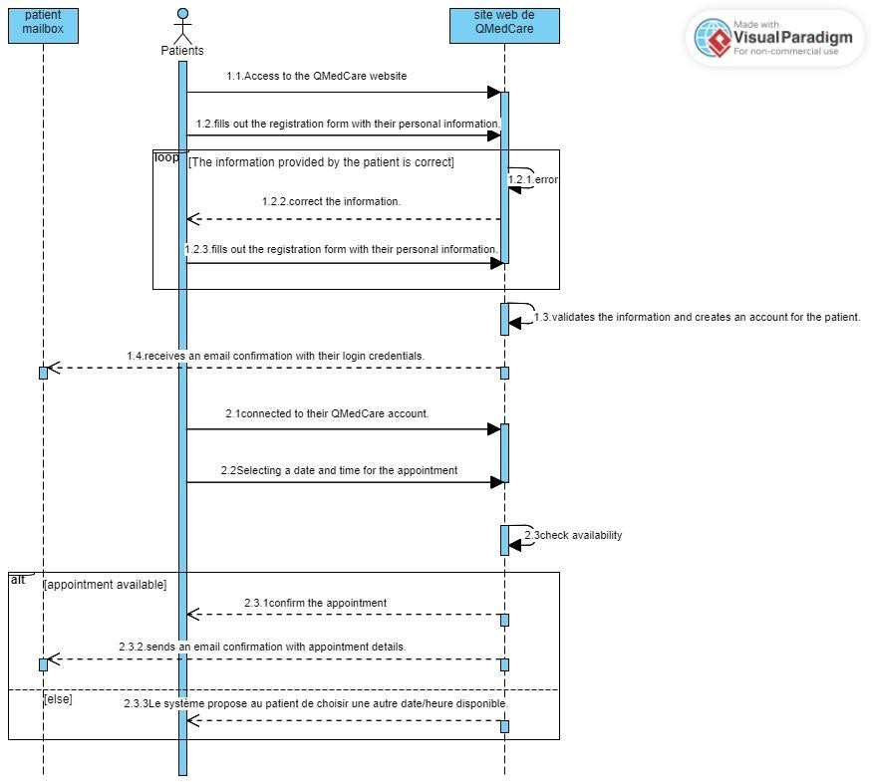

Figure 4. 1

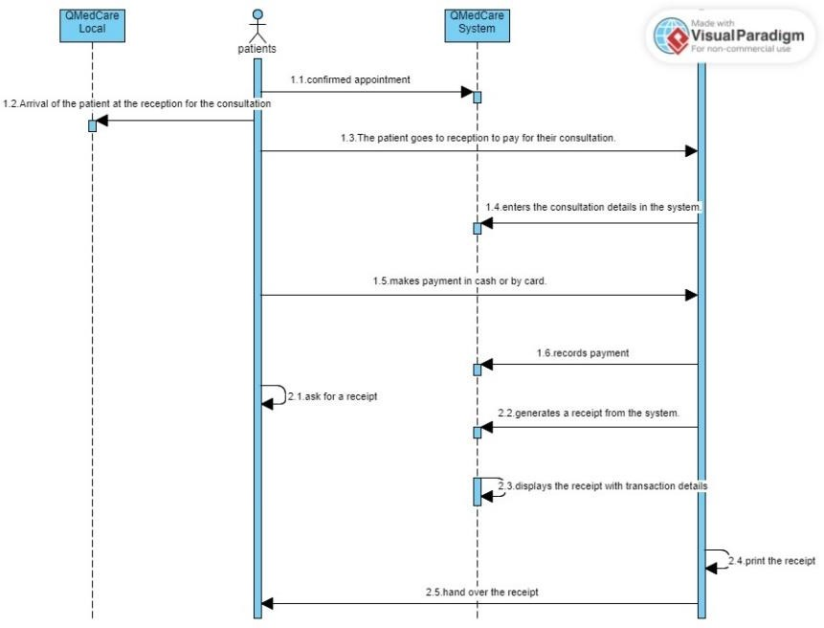

Figure 4. 2

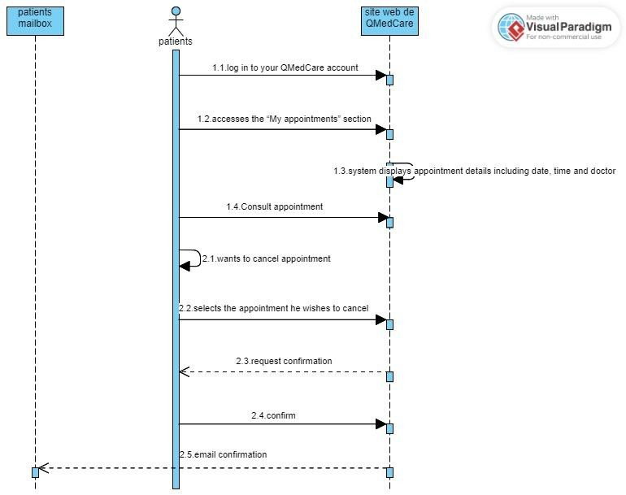

Figure 4. 3

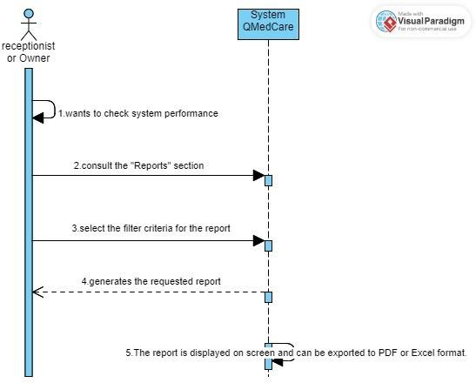

Figure 4. 4

(*Fig 4, Title: Sequence Diagram for* ***UCD no 1* (see Fig. 3.1)** – done by a ROMIAL KAMGAING)

## Sequence Diagram 2 (SD 2)

Figure 5. 1

Figure 5. 2

Figure 5. 3

Figure 5. 4

Figure 5. 5

*(Fig 5, Title: Sequence Diagram* ***for UCD no 2 (see Fig.3.2 )*** *– done by a MEL STEVENS)*

## Sequence Diagram 3 (SD 3)

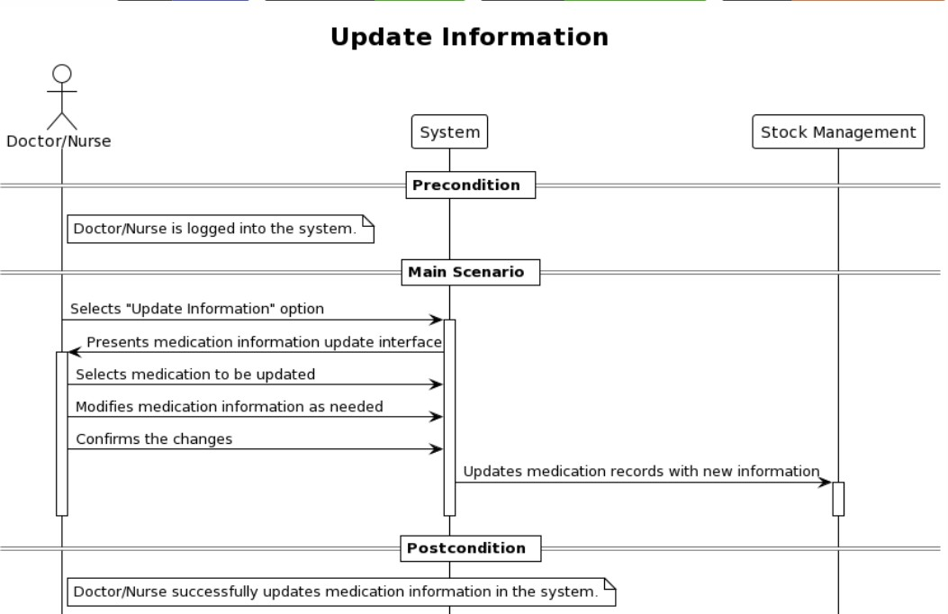

Figure 6. 1

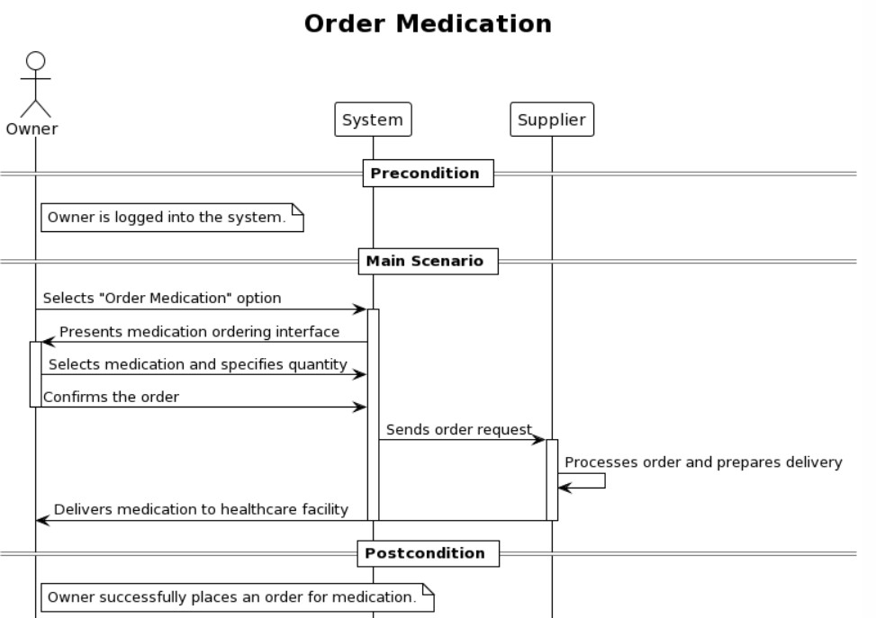

Figure 6. 2

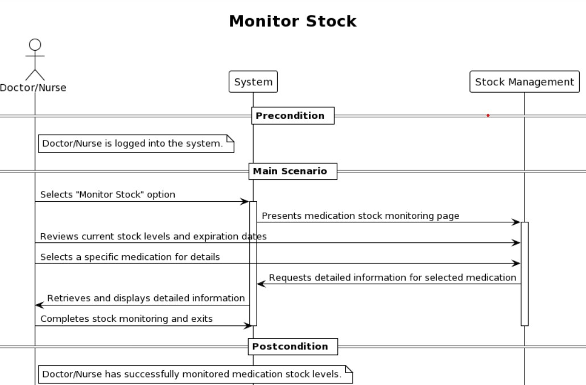

Figure 6. 3

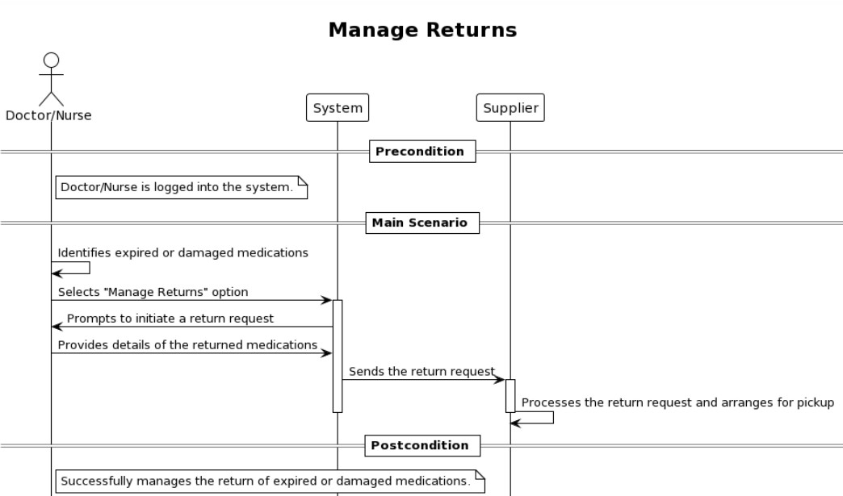

Figure 6. 4

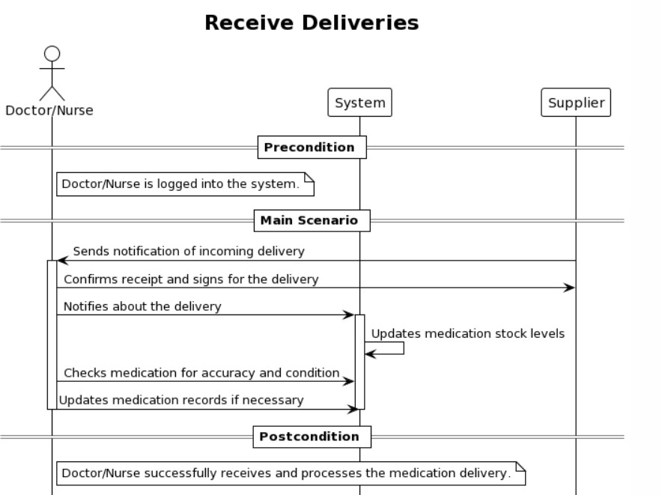

Figure 6. 5

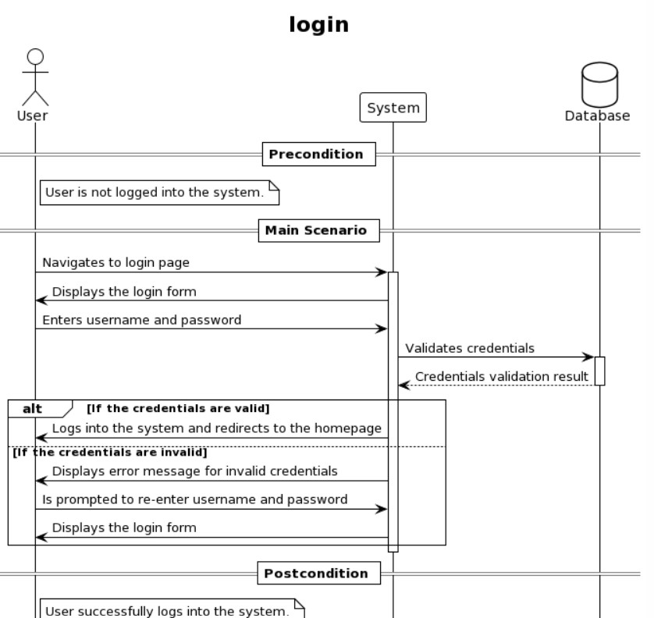

Figure 6. 6

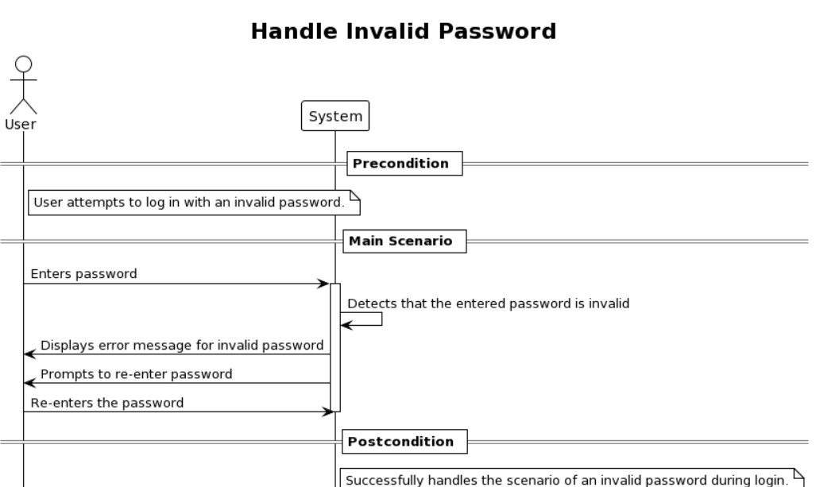

Figure 6. 7

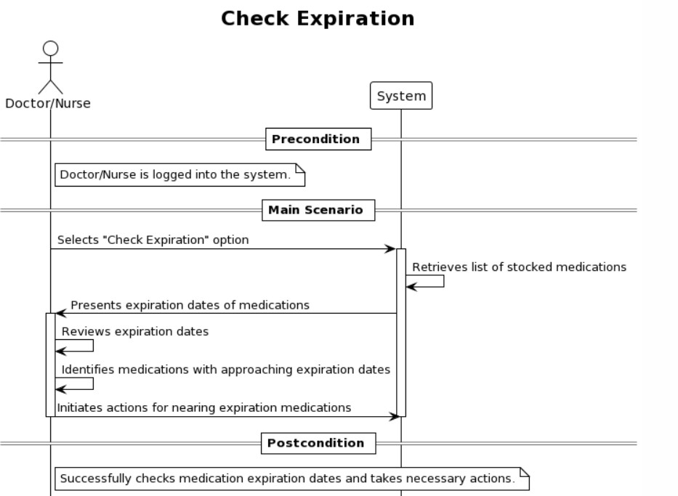

Figure 6. 8

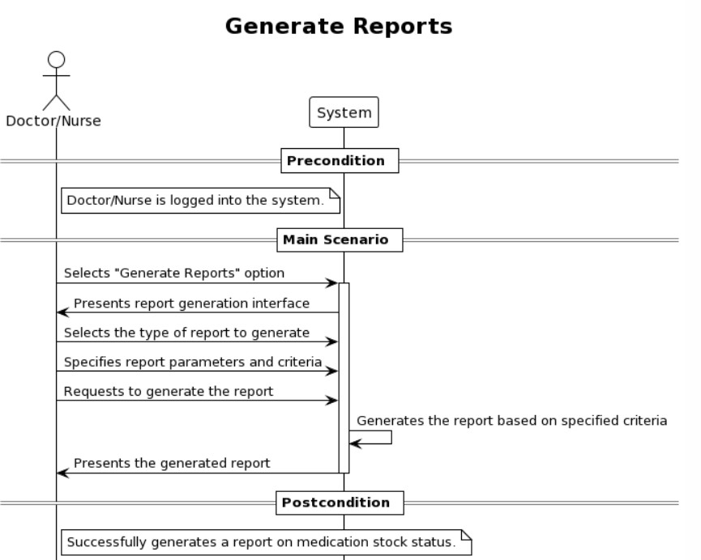

Figure 6. 9

(*Fig 6, Title: Sequence Diagram* ***for UCD no 3* (see Fig. 3.3)** – done by FRANCK WILFRIED)

## Sequence Diagram 4 (SD 4)

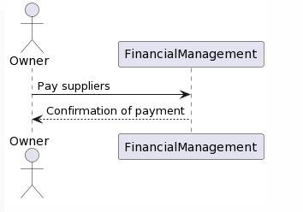

Figure 7. 1

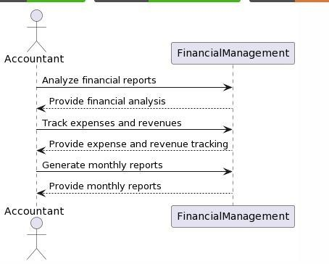

Figure 7. 2

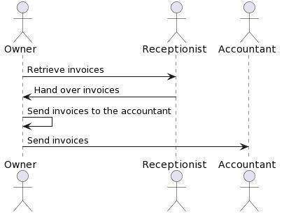

Figure 7. 3

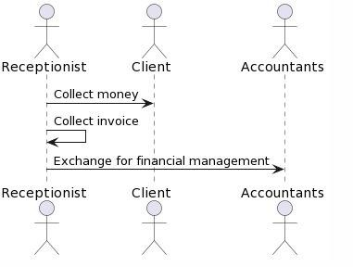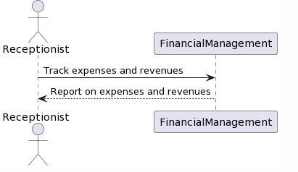

Figure 7. 4

Figure 7. 5

(*Fig 7, Title: Sequence Diagram* ***for UCD no 4* (see Fig. 3.4)** – done by BENOIT DIELE)

# Proposal of a class Diagram

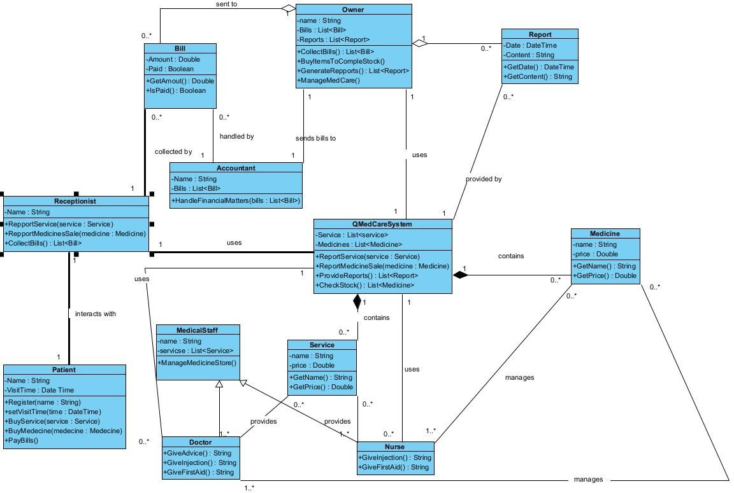

# Conclusions

Our project journey has been enriched by the comprehensive support materials available to us, including course materials and documentation. In addition to leveraging Visual Paradigm, PlantUML, and YouTube tutorials, we have utilized these support materials to deepen our understanding and proficiency in diagram creation.

The course materials have provided us with a structured and systematic approach to learning, covering a wide range of topics related to diagramming techniques, best practices, and methodologies. By immersing ourselves in these materials, we have gained valuable insights into the principles and fundamentals of diagram creation, enabling us to approach our tasks with greater confidence and clarity.

Furthermore, the documentation provided valuable reference resources, allowing us to quickly access information and troubleshoot any challenges encountered during the diagramming process. Whether it was understanding specific syntax in Plant UML or exploring advanced features in Visual Paradigm, the documentation served as a valuable companion in our journey.

By integrating these support materials into our workflow, we have been able to leverage a holistic approach to diagram creation, drawing upon a diverse range of resources to enhance our skills and achieve our objectives. As we continue our project journey, we remain committed to utilizing these valuable resources to further refine our expertise and drive success in our endeavors.